Assignment 3

*[Subtitle]*

Report

Author: Xingrong Zong

Supervisor: [Supervisor]

Semester: VT21

Course code: 2DV608

Table of contents

1 Task 1 – Codebase Analysis 3

2 Task 2 – Re-engineering Plan 7

3 Task 3 – Re-engineering 8

# Task 1 – Codebase Analysis

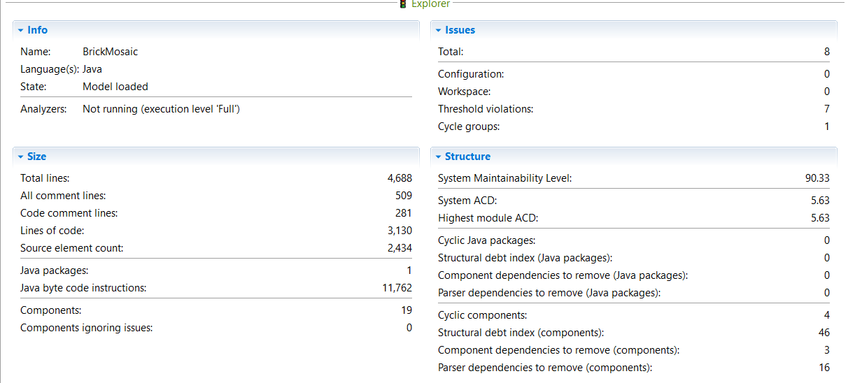

*Figure 1: System Analysis*

In Figure 1 the Size of the system analysis is shown. There are a total of 4688 lines among which 509 lines are comments and 3130 lines are actual code. There are 1 package and 19 components (classes).

In Issues section, there are eight issues detected among which seven of them are threshold violations and the other one is cycle groups.

Under Structure section, it shows the system maintainability level is quite high. The system average component dependency (ACD) is 5.63 which means each class depend on average upon 5.63 other classes. There are four cyclic components which result in a structural debt of 46. To remove all the cyclic dependencies among these four cyclic components there are three dependencies to remove.

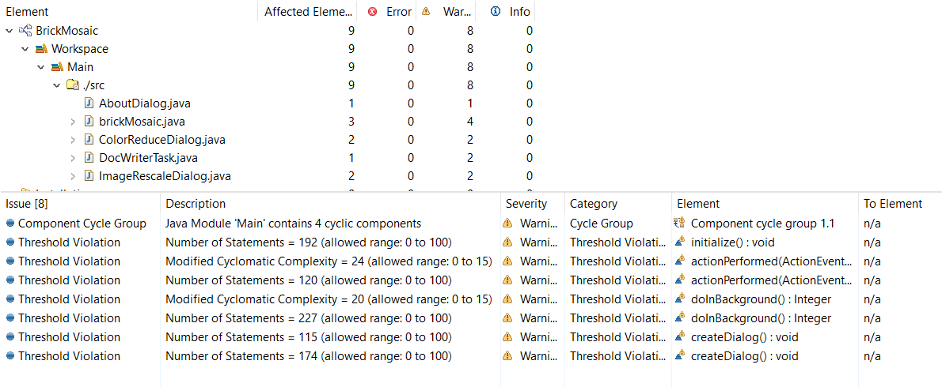

*Figure 2: Issues detected by Sonargraph, 8 warnings*

In Figure 2 the Issues section of the analysis is shown, it shows that there are eight issues detected as already shown in Figure 1. As mentioned, seven of them are threshold violations and one is cycle group. All issues have the severity of a warning.

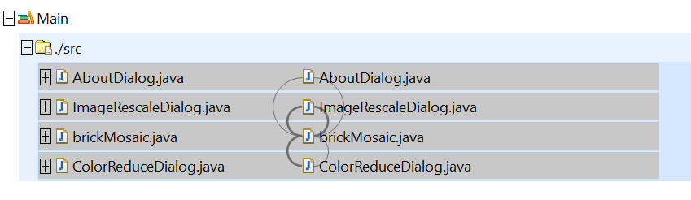

*Figure 3: Cycle Group, 4 cyclic components in exploration view*

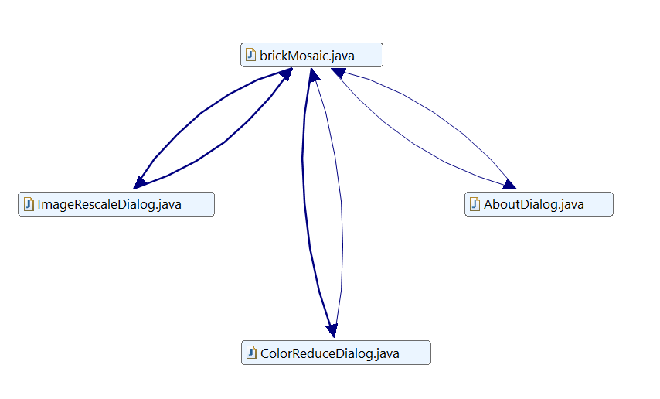

*Figure 4: Component cycle group, 4 cyclic components in cycle view*

In Figure 3 and 4, the dependencies among the cyclic components from the Figure 1 are shown using the exploration view and cycle view of Sonargraph. The classes AboutDialog, imageRescaleDialog, brickMosaic and ColorReduceDialog components have both upward and downward going dependencies which means there is high coupling between the components.

Since this issue only have the severity of a warning, it is not critical for the application but make maintenance more difficult. The source of the problem is probably a bad architecture, if it would for example have used a layered architecture there should not be any upward going dependencies. Each layer should only depend on the layer below.

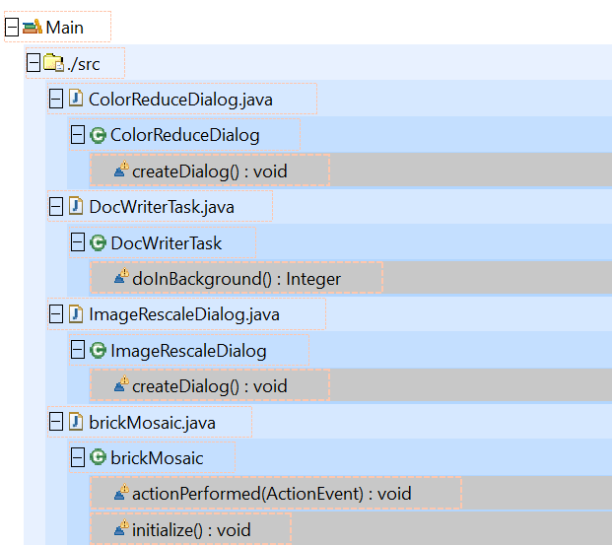

*Figure 5: Threshold violations in exploration view*

Figure 5 shows the issues of threshold violations which are the methods createDialog(), doInBackground, createDialog(), actionPerformed(ActionEvent) and initialize() in four different classes. As seen in Figure 2, the allowed modified cyclomatic complexity is 0 to 15, but methods have 20 and 24. These values mean that the code has 20 and 24 different linearly independent execution paths so technically need 20 and 35 different tests only to test these two methods. It is not that critical because the severity is warning. To solve the problem the method could be split so it would both increase cohesion and decrease complexity. Also, the allowed number of statements should be 0 to 100, but these methods all have over 100 statements. However, they are all at the severity of warning. To solve this issue the duplicate code could be generalize into a method.

# Task 2 – Re-engineering Plan

Remove threshold violations in brickMosaic.java, ImageRescaleDialog.java, DocWriterTask.java, ColorReduceDialog.java

Make duplicate codes into methods.

In order to remove the threshold violations. The plan assumes that the over ranged statements are duplicate codes that can be removed and replaced by methods.

# Task 3 – Re-engineering

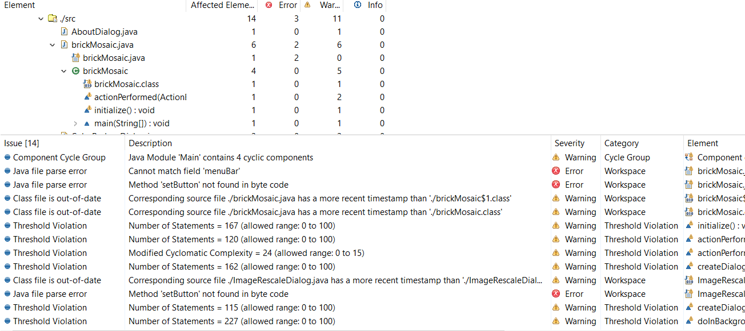

The number of statements decreases a bit, but it shows more issue at severity of error that java file parse error because cannot find the new created parameters and methods.